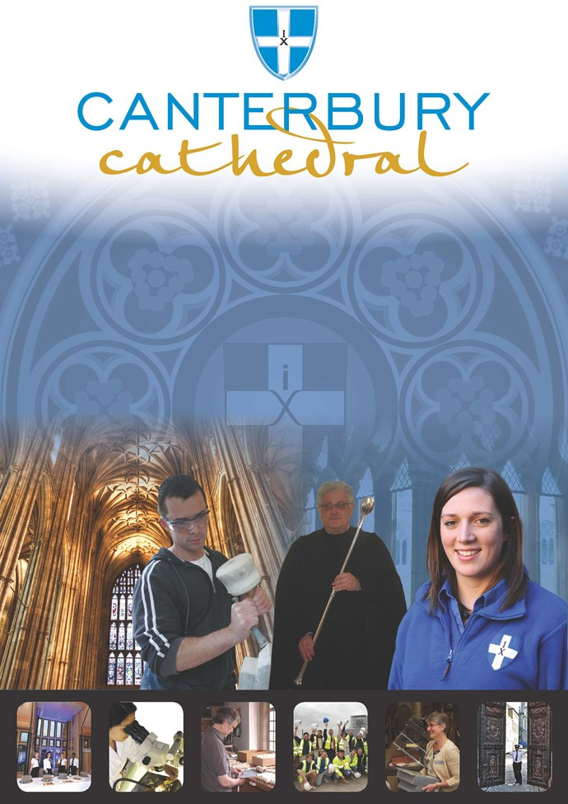

PROFILE OF CANTERBURY CATHEDRAL

St Augustine, the first Archbishop of Canterbury, arrived on the coast of Kent as a missionary to England in 597 AD. He came from Rome, sent by Pope Gregory the Great. It is said that Gregory had been struck by the beauty of Angle slaves he saw for sale in the city market and dispatched Augustine and some monks to convert them to Christianity. Augustine was given a church at Canterbury (St Martin’s, after St Martin of Tours, still standing today) by the local King, Ethelbert whose Queen, Bertha, a French Princess, was already a Christian. This building had been a place of worship during the Roman occupation of Britain and is the oldest church in England still in use. Augustine had been consecrated a bishop in France and was later made an archbishop by the Pope. He established his seat within the Roman city walls (the word cathedral is derived from the Latin word for a chair ‘cathedra’, which is itself taken from the Greek ‘kathedra’ meaning seat.) and built the first cathedral there, becoming the first Archbishop of Canterbury. Since that time, there has been a community around the Cathedral offering daily prayer to God; this community is arguably the oldest organisation in the English speaking world. The present Archbishop, The Most Revd Justin Welby, is 105th in the line of succession from Augustine.
Augustine’s original building lies beneath the floor of the nave– it was extensively rebuilt and enlarged by the Saxons, and the Cathedral was rebuilt completely by the Normans in 1070 following a major fire. There have been many additions to the building over the last nine hundred years, but parts of the quire and some of the windows and their stained glass date from the 12th century.
By 1077, Archbishop Lanfranc had rebuilt it as a Norman church, described as “nearly perfect”. A staircase and parts of the North Wall – in the area of the North West transept also called the Martyrdom – remain from that building.
During the Second World War, the Precincts were heavily damaged by enemy action and the Cathedral’s Library was destroyed. Thankfully, the Cathedral itself was not seriously harmed, due to the bravery of the team of fire watchers, who patrolled the roofs and dealt with the incendiary bombs dropped by enemy bombers.
Today, the Cathedral stands as a place where prayer to God has been offered daily for over 1,400 years; nearly 2,000 services are held each year, as well as countless private prayers from individuals. The Cathedral offers a warm welcome to all visitors – its aim is to show people Jesus, which we do through the splendour of the building as well as the beauty of the worship.

THE WORK OF THE CATHEDRAL
The work of the Cathedral is carried out by over 300 paid staff, supported by some 500 volunteers. The ‘corporate body’ responsible for the management of the Cathedral is the Chapter of Canterbury who are advised by the Cathedral Council and the College of Canons. The Cathedral is well-known all over the world and we welcome more than 1 million visitors and worshippers every year. The Cathedral is more than just a beautiful old building and heritage site; it is a working, living church which maintains a tradition of welcome and worship that has been practiced here for over 1400 years.

The Chapter of Canterbury (Chapter)
The Chapter are responsible for all aspects of the day-to-day management of the Cathedral. Chapter comprises the Dean, the Residentiary Canons, the Receiver General and four additional persons appointed by the Archbishop.

The Cathedral Council
The Council represents the Cathedral community as well as the wider local and regional community. It has 20 members, drawn from a wide variety of organisations. Its duty is to further and support the work of the Cathedral Church in spiritual, pastoral, evangelistic, social and ecumenical areas.

The College of Canons
The College of Canons is composed of 30 Honorary, Lay and Provincial Canons, appointed by the Archbishop and it supports the life of the Cathedral in many different ways.

Canterbury Cathedral Trust
The Cathedral Trust is an independent charity securing support for Canterbury Cathedral. Since 1974, it has assisted with conservation, education and music opportunities at the Cathedral by raising funds for major projects, trade & craft apprenticeships and our choral music tradition.
In recent years, the Trust has provided funding for several major projects, including securing £10.9m in partnership funds to unlock a £13.8m grant from the Heritage Lottery Fund for The Canterbury Journey – a programme of urgent repairs, learning and visitor engagement initiatives.

Friends
The Friends of Canterbury Cathedral was founded in 1927 by the distinguished scholar and poet Dean George Allen Kennedy Bell. The Organisation was the first of its kind in the world. The Friends are the Cathedral’s fan club. Admirers of the building, its history and its community, Friends are a part of the Cathedral and work together to preserve it forever, contributing financially - and directly – to many individual and vital projects.

The Cathedral Shop
The Canterbury Cathedral Shop is a large gift shop in the heart of the city of Canterbury. It has an impressive range of high quality gifts, mostly British, and their own exclusive award winning designs. The Shop’s wide range of merchandise includes replica historical artefacts, books and CD’s of the world-famous Canterbury Cathedral choir.

JOB PROFILE
This exciting and varied role offers a motivated and meticulous person the chance to join a friendly fundraising team at the Cathedral. The post-holder will be the main point of contact for supporter enquiries, information and customer care within the team. A great opportunity for someone wishing to move into fundraising, we are seeking someone with excellent interpersonal skills, a friendly personality and attention to detail. The post-holder will be responsible for record-keeping (using the Trust’s database, Donor Strategy), processing donations, liaising with donors and assisting at events.

REPORTING RELATIONSHIP

This position reports to the Individual Giving Manager, Canterbury Cathedral Trust.

MAIN TASKS

Finance and Administration

Purpose: To ensure the smooth running of the Canterbury Cathedral Trust office. To ensure that income is accurately processed and recorded.

- Work with Finance and other teams to correctly and efficiently manage and reconcile incoming donation information, including cheques, CAF vouchers, Just Giving, Stewardship, online statements, and Gift Aid, enter and code them on Donor Strategy and arrange the appropriate thank you within agreed timescales.
- Maintain efficient processes for managing donor information and income, in line with GDPR.
- Support with the day-to-day administration of legacy gifts.
- Deal with all incoming and outgoing post.
- Maintain resources for the team – stationery, leaflets etc – and organise orders as necessary.

Supporter Care

Purpose: To ensure that supporters of Canterbury Cathedral feel appreciated, informed and are recognised for their contribution (at every level).

- Deal with telephone enquiries and correspondence in a professional and friendly manner.
- Ensure that supporter records and income are accurately recorded on the Donor Strategy database and that all donors receive the information they require in an appropriate, friendly and timely manner.
- Work with colleagues across the organisation to deliver a positive and effective supporter experience of Canterbury Cathedral.
- Support the delivery of fundraising activities eg mailings and events.
- Develop and maintain an informed knowledge of the Cathedral’s operation and function in order to communicate key messages;
- Be an ambassador for the Trust, developing positive relationships across our network of stakeholders, locally, nationally and internationally.
Events

Purpose: As part of our stewardship programme, to deliver interesting, enjoyable and professionally run events.

- Assist with the organisation, promotion and delivery of events for Cathedral supporters, including major donors.
- Manage administration associated with events, including the recording of invitation responses, the production of guest lists and name badges etc.
- Attend events and assist with welcoming guests, signing them in (where appropriate), and ensuring that they run smoothly.

To undertake any other duties reasonably required by the Head of Development.

PERSON SPECIFICATION
The personal specification below indicates the qualifications, experience, knowledge and skills required to undertake the role effectively.

ESSENTIAL KNOWLEDGE AND SKILLS
- Excellent communication skills, both written and verbal.
- A calm, confident friendly and professional manner, able to work with tact and discretion.
- High standards of customer service.
- A good team player, willing to ‘muck in’ to ensure a positive outcome.
- Ability to prioritise and work in an organised and independent manner.
- Excellent attention to detail and commitment to accuracy.
- Core IT skills (ability to use MS Office, MS Outlook, Word and Excel).
- Experience of contact management databases (we use Donor Strategy and full training will be provided).
- A positive, proactive approach to challenges.
- An understanding of and sympathy with the aims and purposes of the Cathedral, its mission and ministry.

DESIRABLE KNOWLEDGE AND SKILLS
- Previous experience of working in a fundraising environment.
- Experience of event coordination.
- A knowledge and excitement about the work of the Cathedral Trust and fundraising in general.
- Flexibility to work outside office hours when the role requires.

TERMS AND CONDITIONS

Grade
6

Duration

The post is offered on a 12 month fixed term contract basis.

Salary
£19,000 - £20,000 per annum, dependent upon relevant experience.

Annual pay reviews
Each year, Chapter consider if a global pay rise is to be awarded to all staff. If a rise is agreed, this is applied to pay from 1st April.
All staff with six months service or more on the 1st April will be eligible for any increase applied. Staff who are not eligible on the 1st April will instead be entitled to any increase applied after 6 months service.
E.G. a member of staff joining in January will not receive a pay rise on 1st April along with other staff. They will receive this rise in July, 6 months after starting.

Working hours
Approximately 37.5 hours per week (excluding breaks) normally Monday to Friday 09.00hrs to 17.00hrs with an unpaid daily lunch break. The post holder should be able to work occasional evening and weekend hours if and when the job requires.

Pension scheme
Canterbury Cathedral Trust offer a Stakeholder pension to all employees. Your age and salary will determine if you are to be automatically enrolled into the pension scheme

Probation Period
All new posts are subject to a probation period. New staff will meet regularly with their line manager to assess both formally and informally progress on work and performance.

Annual holiday

Based upon the hours stated above, the annual entitlement is 25 days plus 8 public holidays and 2 Chapter Days.

Training
Training needs are assessed continuously and appropriate on the job training is provided.

Parking
Chapter is not able to offer staff parking on site.

Staff benefits
We are able to offer a range of staff benefits including discounts in local shops, restaurants and sports centres.

Personal Data
As your employer, the Canterbury Cathedral Trust needs to keep and process information about you for normal employment purposes. The information we hold and process will be used for management and administrative use only. To comply with the General Data Protection Regulations, your acceptance of these terms and conditions gives your consent for your data to be processed.
EQUALITY STATEMENT

Canterbury Cathedral Trust recognises that discrimination and victimisation is unacceptable and that it is in the interests of the organisation and its employees to utilise the skills of the total workforce. It is the aim of the organisation is to ensure that no employee or job applicant receives less favourable facilities or treatment (either directly or indirectly) in recruitment or employment on grounds of age, disability, gender / gender reassignment, marriage / civil partnership, pregnancy / maternity, race, religion or belief, sex, or sexual orientation.
This job description is provided to assist the post holder to know their principal duties. It may be amended from time to time in consultation with you, by, or on behalf of, the Head of the Department, without change to the level of responsibility appropriate to the grading of the post.

HOW TO APPLY
A CV should be submitted on line via our web page.

Application details can be found at:

http://canterbury-cathedral.org/get-involved/employment

The closing date for this post is:
Wednesday 23rd October 2019

Interviews are expected to be held:
Wednesday 30th October 2019

